Control Flows
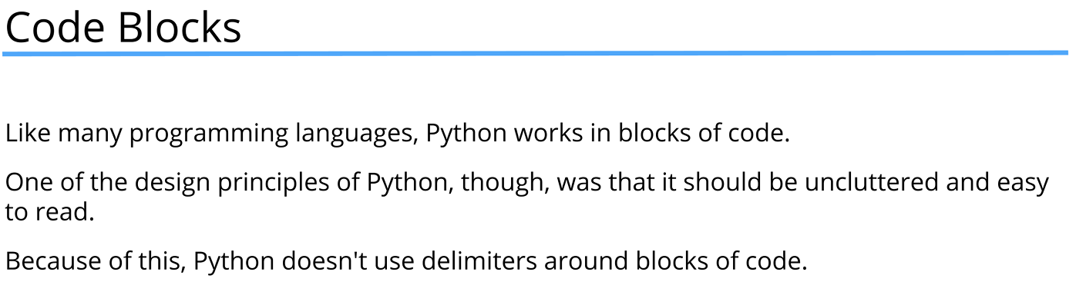
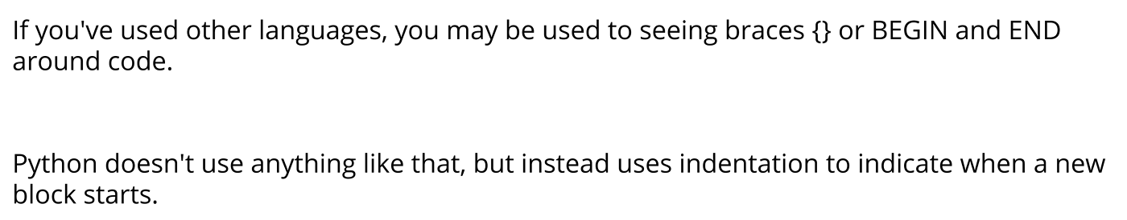
Code blocks

#Code Blocks

#Create a code block with for loop
#: marks the beginning of the block
#after which all lines indented by the same number
#of spaces are part of the block
for i in range(1, 13):
print("No. {} squared is {} and cubed is {:4}"
.format(i, i**2, i**3))
#To remove indentation, use backwards tab
#To indent, use tab or 4 spaces
print("*" * 80) #Output: a line of 80 asterisks

If, elif, else

#if Statements
min_age = 18
#input function gets user input in string format
name = input("Please enter your name: ")
#Convert string to integer using int() function
#If the input is not a valid integer, it raises a ValueError
age = int(input("How old are you, {0}? ".format(name)))
print(age)

#if statement to check condition
#the code block inside the if statement
#is executed only if the condition is True
if age >= min_age:
print("You are old enough to vote!") #Output: You are old enough to vote!
#else block is executed if the condition inside if statement is False
#in any other case the code block inside else is not executed
else:
print("Please come back in {0} years.".format(min_age - age))

print()

#New if else construction marks the beggining of new check which
#is independent of the previous one
if age < 18:
print("Please come back in {0} years.".format(min_age - age))
#elif check is used to check multiple conditions
#elif condition is checked only if the previous
#if or elif conditions were False
#if the elif condition is True,
#the code block inside it is executed
#and the rest elif or else blocks are skipped
#multiple elif checks can be used
elif age == 900:
print("Sorry Yoda you died in Return of the Jedi.")
else:
print("You are old enough to vote!")

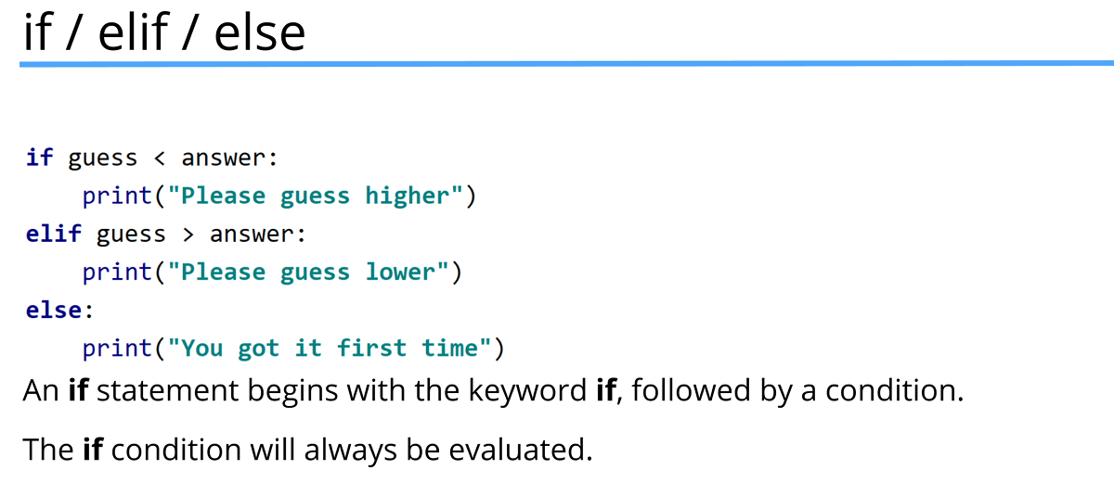

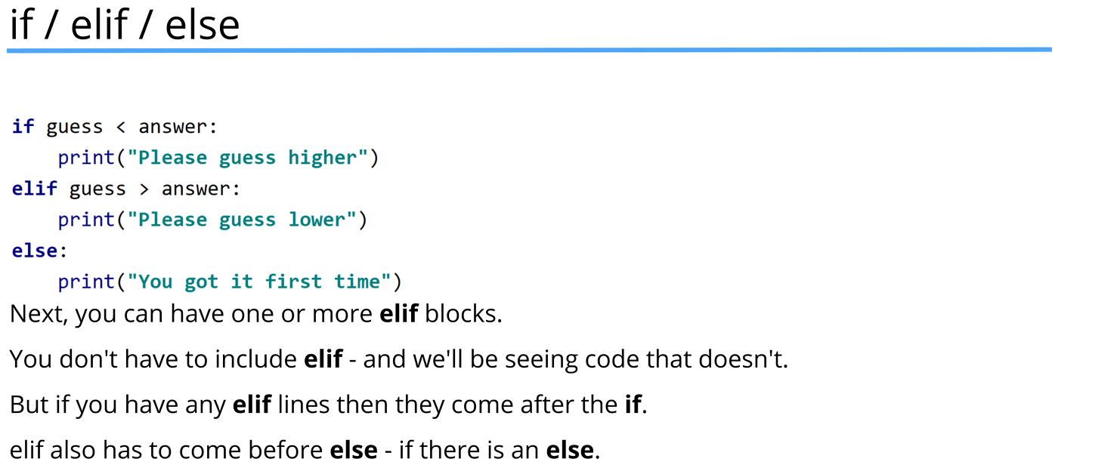

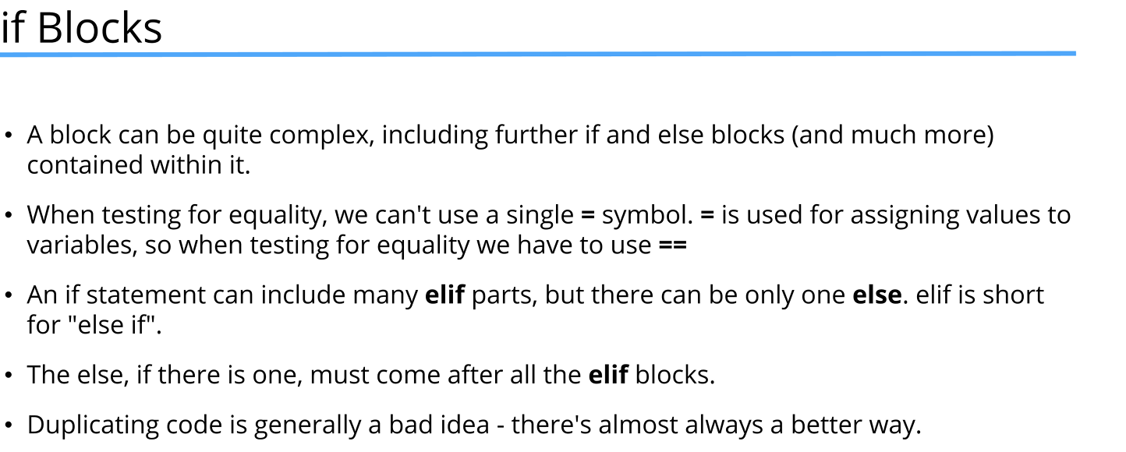
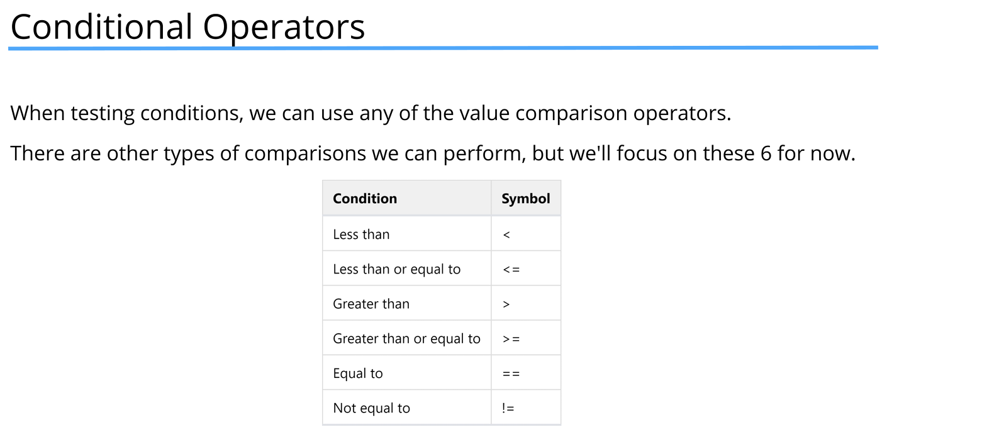
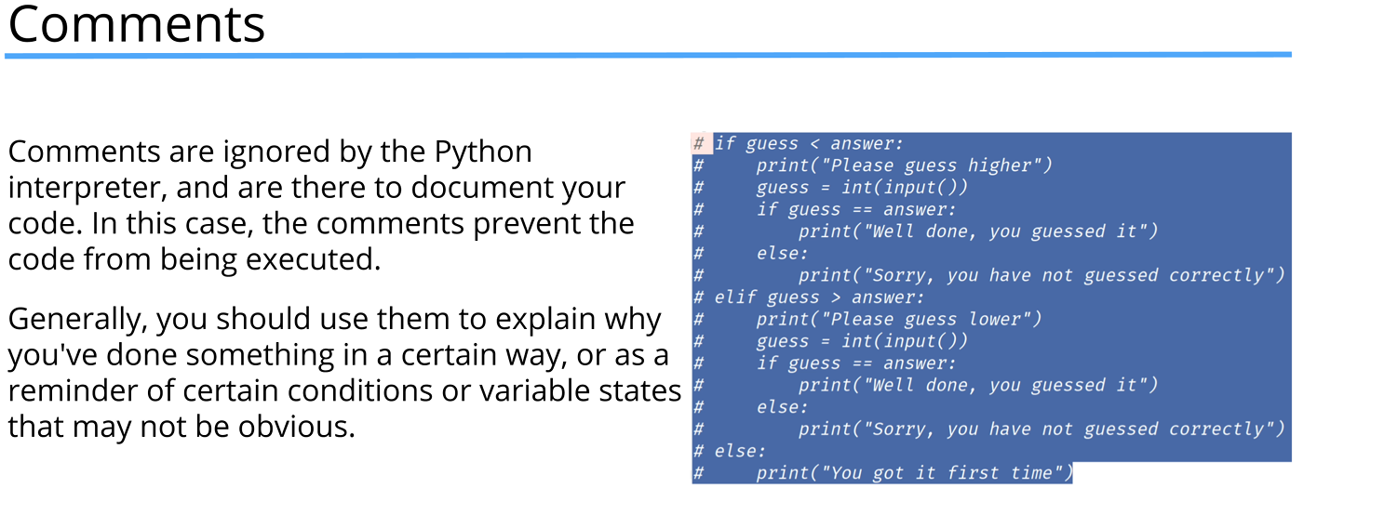
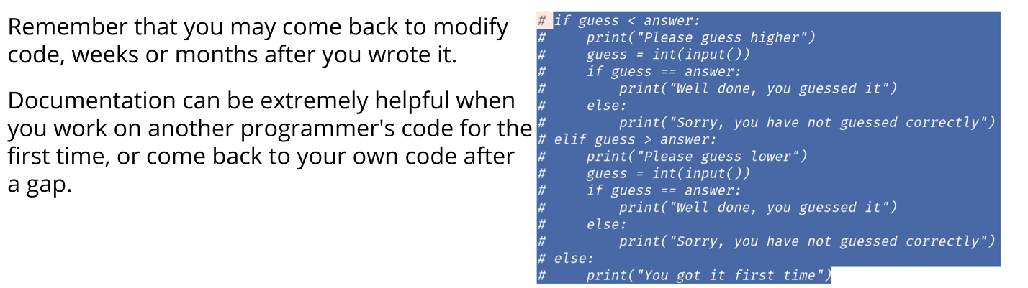
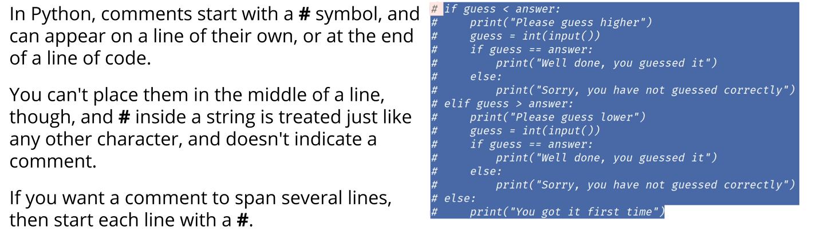
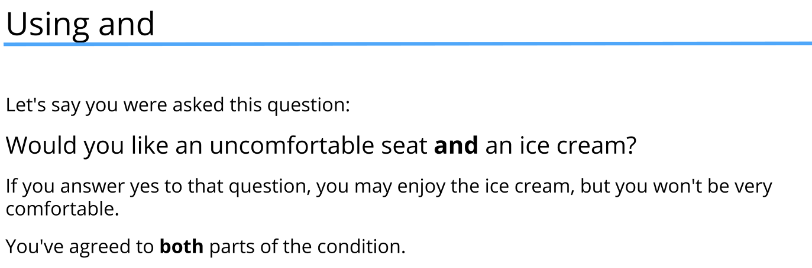
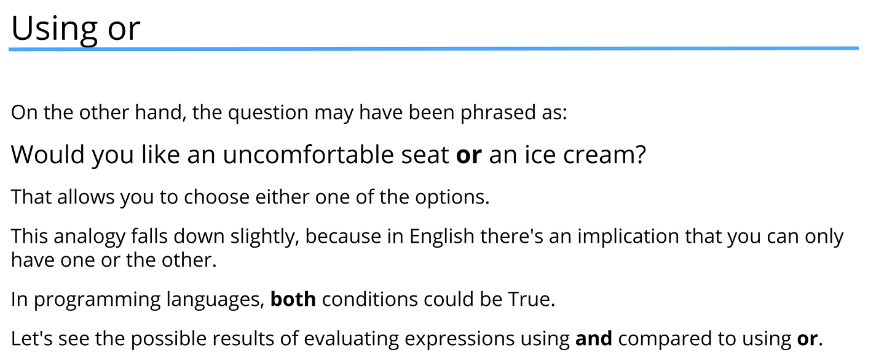
Logical operators table

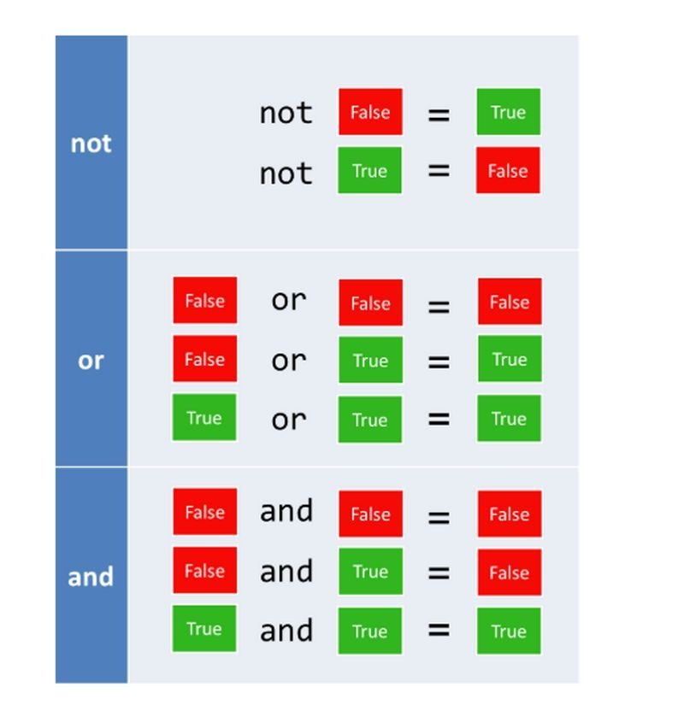
age = int(input("How old are you? "))

# and operator is true if both conditions are true
if age >= 16 and age <= 65:
print("Have a nice day at work!")

print("-" * 80)

#simplified version using chained comparison
if 16 <= age <= 65:
print("Have a nice day at work!")
else:
print("Enjoy your free time!")

print("-" * 80)

# or operator is true if at least one condition is true
if age < 16 or age > 65:
print("Enjoy your free time!")
else:
print("Have a nice day at work!")

print("-" * 80)
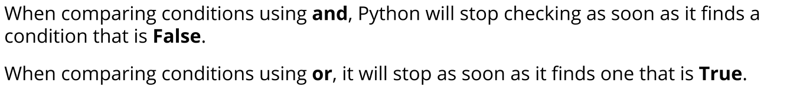
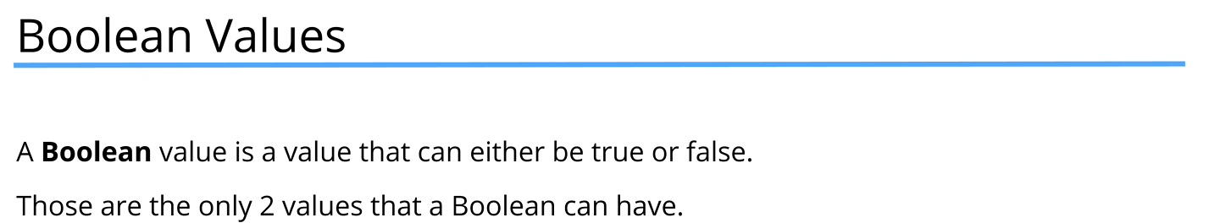
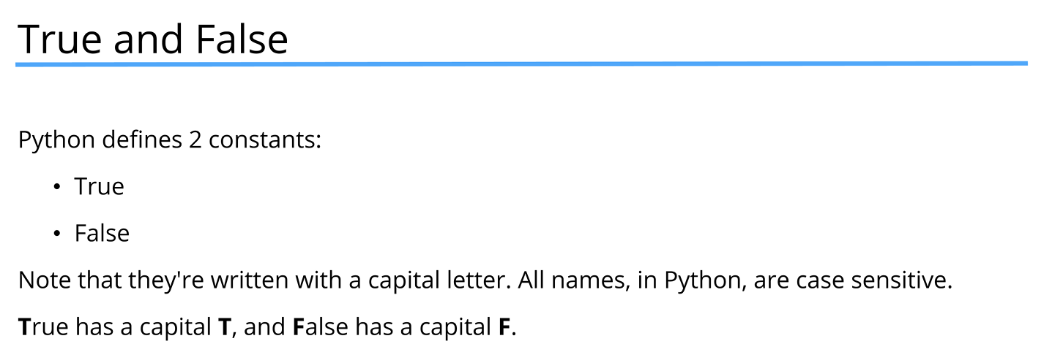

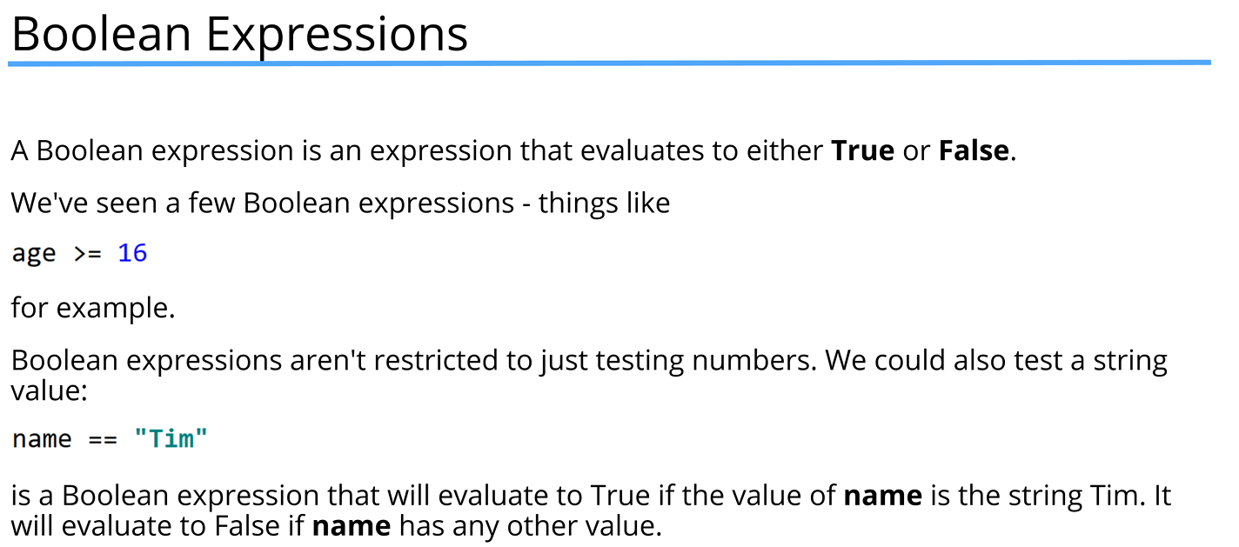
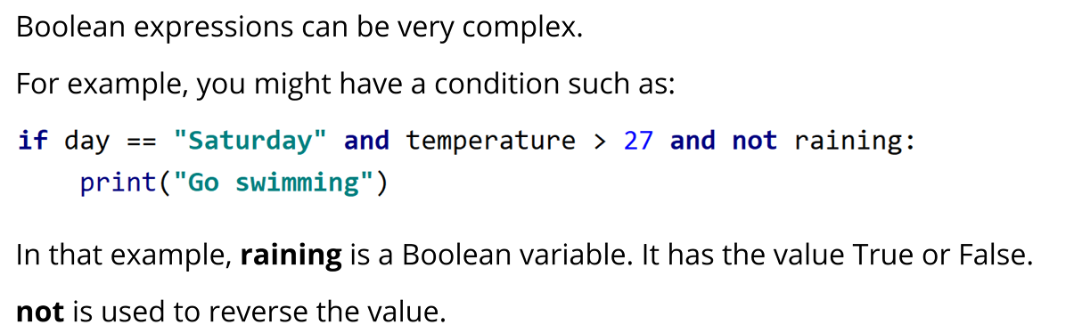

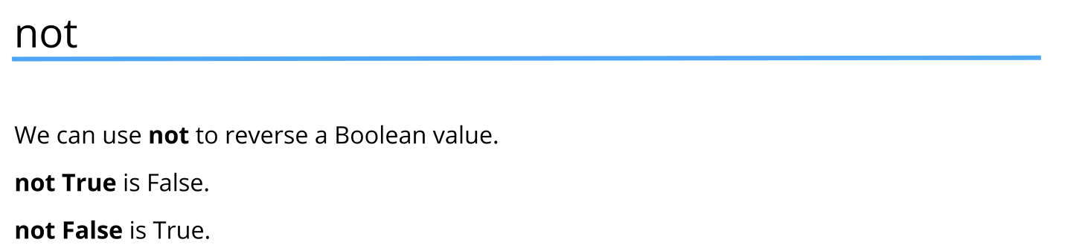
Operator precedence
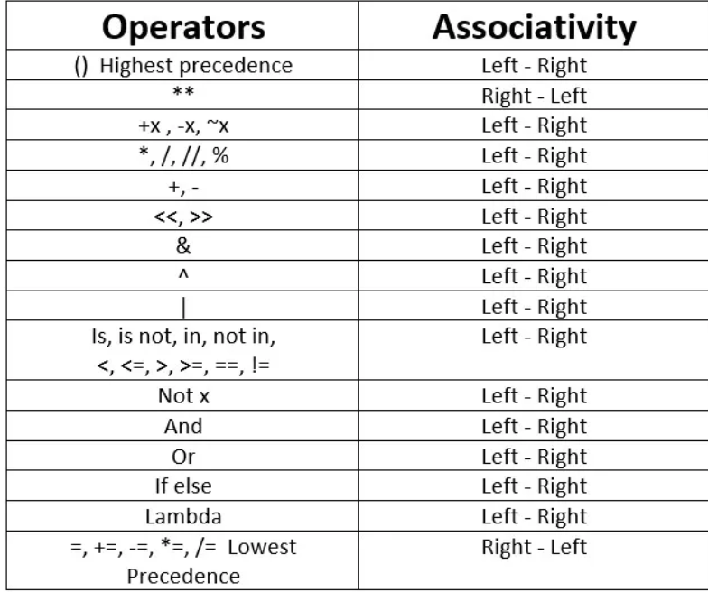

day = "Monday"
temperature = 30
raining = True

#Example of complex boolean expression
#When writing complex boolean expressions,
#use parentheses to make your code more readable
#even when not strictly necessary
#in the example bellow and has higher precedence than or
#but using parentheses makes it clear what the intention is
if (day == "Saturday" and temperature > 27) or not raining:
print("Go swimming")
else:
print("Learn Python")

#Python False values: None, False, 0, "", [], (), {}
#Everything else is True

#Example

name = input("Enter your name: ")

if name:
print("Hello {}".format(name))
else:
print("Are you the man with no name?")

parrot = "Norwegian Blue"
letter = input("Enter a letter: ")

#in operator is used to check if a value exists in a sequence
#behind the scenes, it is doing something like this:
# found = False
# for char in parrot:
# if char == letter:
# found = True
# break
if letter in parrot:
print("{} is in {}".format(letter, parrot))
else:
print("I don't need that letter")

activity = input("What would you like to do today? ")

# not in operator is used to check if a value does not exist in a sequence
# behind the scenes, it is doing something like this:
# found = False
# for item in activity:
# if item == "cinema":
# found = True
# break
# if not found:
# print("But I want to go to the cinema!")
#casefold() is used to make the check case-insensitive
#it converts all characters to lowercase
#it is similar to lower() but more aggressive
# for example, it converts the German letter 'ß' to 'ss'
# this helps in making accurate comparisons
if "cinema" not in activity.casefold():
print("But I want to go to the cinema!")

